**CURRICULAM VITAE**

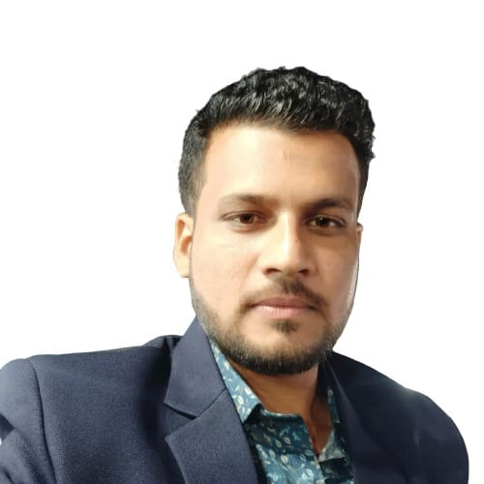 **INDRAJEET N WANKHEDE**

**Contact No: - 9822762451/9689616482**

**E-mail:-indrajeetwankhede123@gmail.comHYPERLINK "mailto:shubhawale@rediffmai**

**OBJECTIVE**

**Challenging & Innovative job profile that will utilize my Agricultural Engineering and Professional Skills and offer Advancement Opportunity.**

**PROFESSIONAL PROFILE**

* **In-Charge (Sales & Service)** at MORA Enviro Pvt. LTD, Pune.
* Around 2 years & 8 months of experience at **Force Motors LTD. in Tractor service department (Marketing)**, Pune.
* B. Tech in **Agricultural Engineering** from College of Agricultural Engineering and Technology, Akola with **7.34** C.G.P.A. - **2016**
* HSC from Municipal Jr. College of Science, Arvi with 77.50%.- **2012**
* SSC from Municipal High School, Arvi with 90.73%.-**2010**

**WORK EXPERIENCE**

**From Sep.2016 to Sep 2017 at Force Motors Ltd. as Graduate Engineer Trainee (GET).**

* **BSR audit** for clearance of tractor in plant.
* Settlements of **service activities** claim and back office work.
* Analysis and follow up with field team for **MSL availability** of spare parts at dealership.
* **Dealership visit** for service support as required.
* **Testing of new tractor at field**.
* Work on DMS (**Dealer Management System)**.
* Analysis of **Product Complaint Report** by field team with superior.
* Visit for conducting and arrangement of **service promotional activities like Mega service camp** at dealership as supervisor.
* **Warranty claim** analysis and settlement.
* Responsible for updating of **Weekly and Monthly MIS reports** of Head Office
* Coordinating **dealer Spare parts work orders in SAP** and Coordinating with accounts team for Financier payments.
* **Achieve inventory planning** and control in such a manner that the **stock is sufficient** for immediate order fulfillment.

**From OCT 17 to April 2019 Force Motors Ltd. (Tractor division) as a Territory service manager(Service Engineer).**

* Improve customer satisfaction & Retention.
* **Service activities, promotions & CSI (Customer Satisfaction Index).**
* **Implementing service policies** and the system lay down by the organization

& its adherence same by the dealers.

* Follow up with dealers to resolve the complaints within set time frames.
* **Conduct service activities like free service camps, customers meet, Mechanic training meet** & initial

Quality to understand from customers his need & desire on the products.

* Planning & **insuring the trained technicians** at all dealership to improve customer satisfaction.
* **Network development** by appointing Authorized Service Center.
* **Provide training** to dealer staff.
* Responsible for after sales activities in field and **technical support.**
* **Spare parts business** with retail handling.
* Maintaining **minimum stock level (MSL)** of spare parts according to organization terms and norms with running and regular billed items.
* **Lube oil business with OEM.**
* Developing **Local mechanic network** and training.
* Analysis of failed part and **product compliant report**.
* **Warranty claim settlements** and approval.
* New product installation at field.
* **New Product Testing.**
* **Troubleshooting at dealership** & failure rework in field with the help of my team.
* **Training of Dealer Management System** to dealer staff and fellow colleague.
* Create **Spare parts work orders** in DMS and Coordinating with accounts team for Financier payments.

**From June 2019 In-Charge (Sales & Service) at MORA Landscape Engineering & Technology, Pune.(MORA Enviro Pvt.Ltd. From April 2022)**

* **Sales and Service Management** of Products with execution.
* **Business Development and Planning** with channel partner and vender.
* **Target achievement** by channel partners and their respective team.
* **Network development** by **appointing new client and vender.**
* **Extension of product** with commercial and **Government official.**
* Improve **customer satisfaction** & Retention.
* Analysis of **product compliant report** and resolve.
* Management, Planning & Execution of Irrigation, Live Vertical Green Wall, Water Bodies & Landscaping Projects and accomplishment it at Pune, Vizag and Hyderabad location.
* **Training to staff & Technician and induction of project.**
* **Procurement of Materials** and Management of Staff at site.
* **Technical support** to technician and site staff.
* **After sales support** and **customer complaint management.**
* Management & Planning of **Annual Maintenance Contract** of Client.
* Vertical Natural Green Wall Marketing, development and irrigation.
* **Automation work of whole system.**
* In-charge of Commercial and Government Project of landscaping and Irrigation
* Sales Management of Product of Green Wall.
* Monitoring the **Payment Disbursement & Collection Process** as per the Scheduled time table provided in the Organization

**SKILLS**

Sales, Service, Network Development, Maintenance, Product installation, PDI, Customer support,Field Sales & Service, Sales & Service Management, Spare Parts Sales and Management, Data Analysis, Warranty, Project Management, Client Handling, Marketing, Field Service, Business Development, Product Technical Support, After Sales Support, Product Installation, Procurement, Purchase Management, Team Planning, Review of Work.

**Soft Skills**

Advance Excel, Word, Power Point. Ms Word etc

**ACHIEVEMENTS**

* Accomplishment of five commercial irrigations and Vertical Green wall Projects in Pune, Hyderabad and Vizag.
* Participated in All India Inter University Sports Meet and State Level Sport in University Volley Ball team.
* NCC C-Certificate with B-Grade.

**TRAINING**

**Southern Region Farm Machinery Training and Testing Institute, Garladinne, Anantapur. (May 2014).**

* Study, Repair, Maintenance, and Overhauling of a 5hp Single Cylinder Diesel Engine.
* Study, Operation, adjustments and maintenance of various Agricultural Implements, Machines, Plant Protection Equipments and Irrigation Pumps.

**N.M. Sadguru Water and Development Foundation, Dahod, Gujrat. (June 2015)**

* “Village survey for planning of various watershed interventions & their feasibility”

**Netafim Irrigation India Pvt.Ltd. (January- April 2016)**

* Summer Internship Project.
* Netafim Drip Irrigation System- Basic concept, drip design, installation, operation and maintenance.

**INTERESTS**

Travelling, Visit New Places, Sports.

**PERSONAL PROFILE**

DOB : 22.01.1994

Father name : Narendra B. Wankhede

Mother tongue : MARATHI

Nationality : INDIAN

Marital Status : SINGLE

Languages : MARATHI,HINDI,ENGLISH

Permanent address : JAJOO WADI, ARVI,

DIST-WARDHA (M.H)- 442201

**DECLARATION**

I hereby solemnly declared that the information furnished above to the best of my knowledge.

**Date**: - With Regards,

**Place:** - Pune **Indrajeet Wankhede.**